

Grau en Enginyeria Informàtica de Gestió i Sistemes d’Informació

Desenvolupament d’un Framework per programar Utility-Based AI

Annexos

Jordi Romagosa i Mellado

Tutor: Enric Sesa i Nogueras

Curs 2017- 2018



**Introducció**

L’objectiu d’aquests annexes és proporcionar la documentació necessària per facilitar tant la lectura de la memòria com la valoració de la codificació. S’han agrupat les diverses taules i figures de la memòria per facilitar-ne la consulta i per accedir amb facilitat a la informació en els diversos apartats de la memòria, en cas que el lector ho necessiti. Només s’han incorporat les figures i taules rellevants pel disseny i programació tant del framework com de la simulació. Pel mateix motiu, també s’ha fet el recull del codi de programació tant del framework com dels scripts i classes de la simulació.

Índex

1 Annex I - Recull de figures i taules 3

1.1 Recull de figures i taules del framework 3

1.1.1 Figura 7.1 Diagrama de classes del framework 3

1.1.2 Taula 7.1 Classes que hereten de UtilityFuncion 4

1.1.3 Figura 7.2 Diagrama de seqüència del framework 5

1.2 Recull de figures i taules de la simulació 5

1.2.1 Taula 9.1 Atributs del personatge 5

1.2.2 Taula 9.2 Accions del personatge 6

1.2.3 Figura 9.5 Diagrama de classes de la simulació 7

2 Annex II - Codificació 9

2.1 Codificació del framework 9

2.1.1 Action 9

2.1.2 Context 9

2.1.3 BestActionCalculation 10

2.1.4 UtilityFunction 12

2.1.5 ConstantUtilityFunction 12

2.1.6 ComposedUtilityFunction 13

2.1.7 LinearUtilityFunction 13

2.1.8 LogisticUtilityFunction 14

2.1.9 LogitUtilityFunction 15

2.1.10 QuadraticUtilityFunction 16

2.2 Codificació de la simulació 17

2.2.1 ActionInformation 17

2.2.2 Atribute 17

2.2.3 GameController 19

2.2.4 GameState 23

2.2.5 UIAtribute 24

2.2.6 UIController 24

3 Annex III - Contingut del CD 27

# Annex I - Recull de figures i taules

En aquesta secció es mostra el recull de figures i taules de la memòria que s’ha considerat que són prou rellevants com perquè el lector hi hagi de poder accedir amb facilitat. Les figures i taules apareixen classificades i en el mateix ordre que apareixen en la memòria. S’han numerat seguint la numeració de la memòria per mantenir la relació.

## Recull de figures i taules del framework

### Figura 7.1 Diagrama de classes del framework

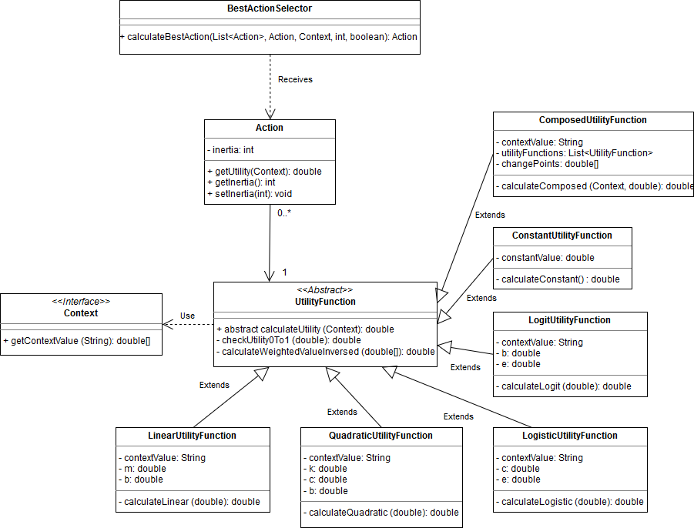

### Taula 7.1 Classes que hereten de UtilityFuncion

|  |  |  |
| --- | --- | --- |
| **Nom** | **Funció de càlcul** | **Representació gràfica** |
| Linear | $$y = mx + b$$ |  |
| Quadratic | $$y = {(x - c)}^{k} + b$$ |  |
| Constant | $$y = b$$ |  |
| Logistic | $y = \frac{1}{1+ e^{-x+c}}$ |  |
| Logit | $$y=\log_{e}\left(\frac{x}{1-x}\right) + b$$ |  |
| Composed | $$y=\left\{\begin{aligned}mx+b, &x<0,5 \\ b, &x≥0.5\end{aligned}\right.$$ |  |

### Figura 7.2 Diagrama de seqüència del framework

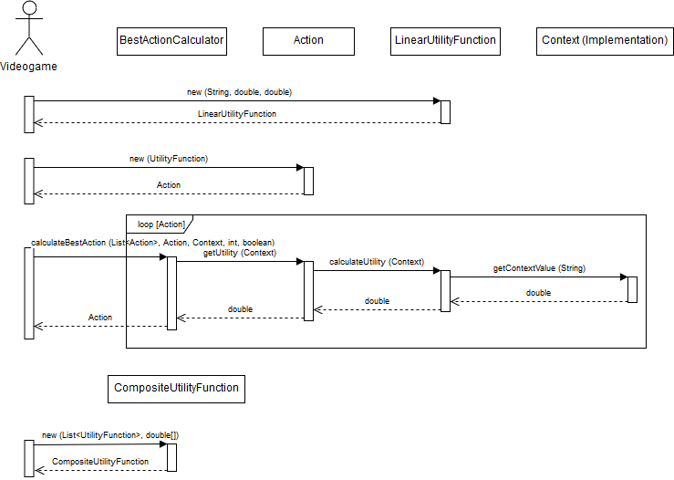

## Recull de figures i taules de la simulació

### Taula 9.1 Atributs del personatge

|  |  |  |  |
| --- | --- | --- | --- |
| **Atribut** | **Màxim** | **Mínim** | **Modificador** |
| Fullness | 100 | 0 | -3 |
| Awake | 100 | 0 | -1 |
| Relax | 100 | 0 | -1 |
| Clean | 100 | 0 | -1 |
| Money | 100 | 0 | -2 |
| Energy | 100 | 0 | +1 |

### Taula 9.2 Accions del personatge

|  |  |  |  |
| --- | --- | --- | --- |
| **Acció** | **Unitats de Temps** | **Atribut** | **Modificador** |
| Eat | 4 | Fullness | +10 |
| Sleep | 8 | Awake | +5 |
| Relax | +1 |
| Work | 6 | Money | +8 |
| Relax | -4 |
| Exercise | 4 | Relax | +15 |
| Clean | -5 |
| Energy | -10 |
| Watch TV | 2 | Relax | +10 |
| Shower | 3 | Clean | +40 |

### Figura 9.5 Diagrama de classes de la simulació

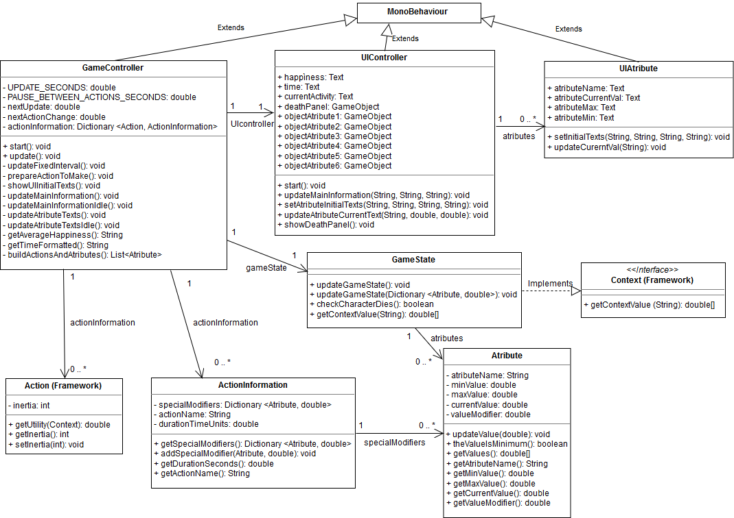

# Annex II - Codificació

En aquesta secció s’ha escrit la codificació del framework i de la simulació, per poder consultar en cas de necessitat durant la lectura de la memòria. S’ha decidit escriure la codificació sencera degut a que aquesta no és massa extensa.

## Codificació del framework

### Action

using System;

namespace UtilityAI

{

public class Action

{

private double inertia;

private UtilityFunction utilityFunction;

public Action(double inertia, UtilityFunction utlityFunction)

{

this.inertia = inertia;

this.utilityFunction = utlityFunction;

}

public Action(UtilityFunction utilityFunction) : this(0, utilityFunction) { }

public double Inertia { get => inertia; set => inertia = value; }

public double GetUtility(Context context)

{

return utilityFunction.CalculateUtility(context);

}

}

}

### Context

using System;

namespace UtilityAI

{

public interface Context

{

double[] GetContextValue(String valueName);

}

}

### BestActionCalculation

using System;

using System.Collections.Generic;

using System.Linq;

namespace UtilityAI

{

public class BestActionCalculator

{

public const int BEST_ACTION = 0;

public const int WEIGHTED_RANDOM = 1;

public const int RANDOM_BEST_3 = 2;

public static Action CalculateBestAction(List<Action> actions, Action currentAction, Context context, int chooseMethod, Boolean useInertia)

{

switch (chooseMethod)

{

case BEST_ACTION:

return BestActionMethod(actions, currentAction, context, useInertia);

case WEIGHTED_RANDOM:

return WeightedRandomMethod(actions, currentAction, context, useInertia);

case RANDOM_BEST_3:

return RandomBest3Method(actions, currentAction, context, useInertia);

default:

return DefaultActionChoose(actions, currentAction);

}

}

private static Action DefaultActionChoose(List<Action> actions, Action currentAction)

{

if (currentAction != null) return currentAction;

int randomIndex = new Random().Next(actions.Count);

return actions[randomIndex];

}

private static double ApplyInertiaToUtility(double baseUtility, double inertiaValue)

{

if (inertiaValue > 1) inertiaValue = 1;

else if (inertiaValue < 0) inertiaValue = 0;

return baseUtility + baseUtility * inertiaValue;

}

private static Action BestActionMethod(List<Action> actions, Action currentAction, Context context, Boolean useInertia)

{

Action bestAction = actions[0];

actions.RemoveAt(0);

double bestUtility = bestAction.GetUtility(context);

if (useInertia && bestAction.Equals(currentAction))

bestUtility = ApplyInertiaToUtility(bestUtility, bestAction.Inertia);

foreach (Action action in actions){

double currentActionUtility = action.GetUtility(context);

if (useInertia && action.Equals(currentAction))

currentActionUtility = ApplyInertiaToUtility(currentActionUtility, action.Inertia);

if (currentActionUtility > bestUtility)

{

bestAction = action;

bestUtility = currentActionUtility;

}

}

return bestAction;

}

private static Action WeightedRandomMethod(List<Action> actions, Action currentAction, Context context, Boolean useInertia)

{

List<KeyValuePair<Action, double>> actionUtilityPairs = new List<KeyValuePair<Action, double>>();

double accumulatedUtility = 0;

foreach (Action action in actions)

{

double currentActionUtility = action.GetUtility(context);

if (useInertia && action.Equals(currentAction))

currentActionUtility = ApplyInertiaToUtility(currentActionUtility, action.Inertia);

accumulatedUtility += currentActionUtility;

actionUtilityPairs.Add(new KeyValuePair<Action, double>(action, accumulatedUtility));

}

double random = new Random().NextDouble() * accumulatedUtility;

foreach (KeyValuePair<Action, double> actionUtilityPair in actionUtilityPairs)

{

if (random < actionUtilityPair.Value)

return actionUtilityPair.Key;

}

return currentAction;

}

private static Action RandomBest3Method(List<Action> actions, Action currentAction, Context context, Boolean useInertia)

{

Dictionary<Action, double> actionUtilityPairs = new Dictionary<Action, double>();

foreach (Action action in actions) {

double currentActionUtility = action.GetUtility(context);

if (useInertia && action.Equals(currentAction))

currentActionUtility = ApplyInertiaToUtility(currentActionUtility, action.Inertia);

actionUtilityPairs.Add(action, currentActionUtility);

}

var items = from pair in actionUtilityPairs orderby pair.Value descending select pair;

Dictionary<Action, double> bestActionUtilityPairs = new Dictionary<Action, double>();

foreach (KeyValuePair<Action, double> pair in items)

{

if (bestActionUtilityPairs.Count > 3)

break;

bestActionUtilityPairs.Add(pair.Key, pair.Value);

}

return bestActionUtilityPairs.ElementAt(new Random().Next(0, bestActionUtilityPairs.Count)).Key;

}

}

}

### UtilityFunction

using System;

namespace UtilityAI

{

public abstract class UtilityFunction

{

public abstract double CalculateUtility(Context context);

protected double CalculateWeightedValueInversed(double[] values)

{

double maxValue = values[0];

double minValue = values[1];

double currentValue = values[2];

double weightedValue = (currentValue - minValue) / (maxValue - minValue);

return -weightedValue + 1;

}

protected double CheckUtility0To1(double utility)

{

if (utility > 1) return 1;

else if (utility < 0) return 0;

return utility;

}

}

}

### ConstantUtilityFunction

using System;

using System.Collections.Generic;

using System.Text;

namespace UtilityAI.UtilityFunctionImplementations

{

public class ConstantUtilityFunction : UtilityFunction

{

double constantValue;

public ConstantUtilityFunction(double constantValue)

{

this.constantValue = constantValue;

}

public override double CalculateUtility(Context context)

{

double utility = CalculateConstant();

return CheckUtility0To1(utility);

}

private double CalculateConstant()

{

return constantValue;

}

}

}

### ComposedUtilityFunction

using System;

using System.Collections.Generic;

using System.Linq;

namespace UtilityAI.UtilityFunctionImplementations

{

public class ComposedUtilityFunction : UtilityFunction

{

private String contextValue;

private List<UtilityFunction> utilityFunctions;

private double[] changePoints;

public ComposedUtilityFunction(string contextValue, List<UtilityFunction> utilityFunctions, double[] changePoints)

{

this.contextValue = contextValue;

this.utilityFunctions = utilityFunctions;

this.changePoints = changePoints;

}

public override double CalculateUtility(Context context)

{

double[] valueState = context.GetContextValue(contextValue);

double currentWeightedValue = CalculateWeightedValueInversed(valueState);

double utility = CalculateComposed(context, currentWeightedValue);

return CheckUtility0To1(utility);

}

private double CalculateComposed(Context context, double x)

{

int functionChosen = 0;

foreach (double n in changePoints)

{

if (x < n) break;

else functionChosen++;

}

return utilityFunctions.ElementAt(functionChosen).CalculateUtility(context);

}

}

}

### LinearUtilityFunction

using System;

namespace UtilityAI.UtilityFunctionImplementations

{

public class LinearUtilityFunction : UtilityFunction

{

private String contextValue;

private double m;

private double b;

public LinearUtilityFunction(string contextValue, double m, double b)

{

this.contextValue = contextValue;

this.m = m;

this.b = b;

}

public override double CalculateUtility(Context context)

{

double[] valueState = context.GetContextValue(contextValue);

double currentWeightedValue = CalculateWeightedValueInversed(valueState);

double utility = CalculateLinear(currentWeightedValue);

return CheckUtility0To1(utility);

}

private double CalculateLinear(double x)

{

return m * x + b;

}

}

}

### LogisticUtilityFunction

using System;

namespace UtilityAI.UtilityFunctionImplementations

{

public class LogisticUtilityFunction : UtilityFunction

{

private String contextValue;

private double c;

private double e;

public LogisticUtilityFunction(string contextValue, double c, double e)

{

this.contextValue = contextValue;

this.c = c;

this.e = e;

}

public override double CalculateUtility(Context context)

{

double[] valueState = context.GetContextValue(contextValue);

double currentWeightedValue = CalculateWeightedValueInversed(valueState);

double utility = CalculateLogistic(currentWeightedValue);

return CheckUtility0To1(utility);

}

private double CalculateLogistic(double x)

{

double power = -x + c;

return 1 / (1 + Math.Pow(e, power));

}

}

}

### LogitUtilityFunction

using System;

using System.Collections.Generic;

using System.Text;

namespace UtilityAI.UtilityFunctionImplementations

{

public class LogitUtilityFunction : UtilityFunction

{

private String contextValue;

private double b;

private double e;

public LogitUtilityFunction(string contextValue, double b, double e)

{

this.contextValue = contextValue;

this.b = b;

this.e = e;

}

public override double CalculateUtility(Context context)

{

double[] valueState = context.GetContextValue(contextValue);

double currentWeightedValue = CalculateWeightedValueInversed(valueState);

double utility = CalculateLogit(currentWeightedValue);

return CheckUtility0To1(utility);

}

private double CalculateLogit(double x)

{

double number = x / (1 - x);

return Math.Log(number, e) + b;

}

}

}

### QuadraticUtilityFunction

using System;

namespace UtilityAI.UtilityFunctionImplementations

{

public class QuadraticUtilityFunction : UtilityFunction

{

private String contextValue;

private double k;

private double c;

private double b;

public QuadraticUtilityFunction(string contextValue, double k, double c, double b)

{

this.contextValue = contextValue;

this.k = k;

this.c = c;

this.b = b;

}

public override double CalculateUtility(Context context)

{

double[] valueState = context.GetContextValue(contextValue);

double currentWeightedValue = CalculateWeightedValueInversed(valueState);

double utility = CalculateQuadratic(currentWeightedValue);

return CheckUtility0To1(utility);

}

private double CalculateQuadratic(double x)

{

return Math.Pow((x - c), k) + b;

}

}

}

## Codificació de la simulació

### ActionInformation

using System.Collections.Generic;

namespace Assets.Scripts

{

public class ActionInformation

{

private Dictionary<Atribute, double> specialModifiers;

private string actionName;

private double durationTimeUnits;

public double DurationSeconds

{

get { return durationTimeUnits; }

}

public string ActionName {

get { return actionName; }

}

public ActionInformation(string actionName, double durationTimeUnits)

{

this.specialModifiers = new Dictionary<Atribute, double>();

this.actionName = actionName;

this.durationTimeUnits = durationTimeUnits;

}

public Dictionary<Atribute, double> GetSpecialModifiers()

{

return specialModifiers;

}

public void AddSpecialModifier(Atribute atribute, double modifier)

{

specialModifiers.Add(atribute, modifier);

}

}

}

### Atribute

using System;

namespace Assets.Scripts

{

public class Atribute

{

private String atributeName;

private double minValue;

private double maxValue;

private double currentValue;

private double valueModifier;

public Atribute(string atributeName, double minValue, double maxValue, double valueModifier)

{

this.atributeName = atributeName;

this.minValue = minValue;

this.maxValue = maxValue;

this.currentValue = maxValue;

this.valueModifier = valueModifier;

}

public String AtributeName

{

get { return atributeName; }

}

public double MinValue

{

get { return minValue; }

}

public double MaxValue

{

get { return maxValue; }

}

public double CurrentValue

{

get { return currentValue; }

}

public double ValueModifier

{

get { return valueModifier; }

}

public void UpdateValue()

{

UpdateValue(valueModifier);

}

public void UpdateValue(double valueModifier)

{

currentValue += valueModifier;

if (currentValue > maxValue)

currentValue = maxValue;

else if (currentValue < minValue)

currentValue = minValue;

}

public Boolean TheValueIsMinimum()

{

return currentValue <= minValue;

}

public double[] GetValues()

{

double[] result = { maxValue, minValue, currentValue };

return result;

}

}

}

### GameController

using UtilityAI;

using UtilityAI.UtilityFunctionImplementations;

using Assets.Scripts;

using System.Collections.Generic;

using UnityEngine;

public class GameController : MonoBehaviour {

private const double UPDATE_SECONDS = 1;

private const double PAUSE_BETWEEN_ACTIONS_SECONDS = UPDATE_SECONDS;

private double nextUpdate;

private double nextActionChange;

private double lastActionChange;

private GameState gameState;

private Dictionary<Action, ActionInformation> actionInformation;

private Action currentAction;

public UIController UIcontroller;

void Start ()

{

nextUpdate = Mathf.FloorToInt(Time.time) + UPDATE_SECONDS;

actionInformation = new Dictionary<Action, ActionInformation>();

List<Atribute> atributes = BuildActionsAndAtributes();

gameState = new GameState(atributes);

PrepareActionToMake();

ShowUIInitialTexts();

UpdateMainInformation();

UpdateAtributeTexts();

}

void Update()

{

if (Time.time >= nextUpdate)

{

nextUpdate = nextUpdate + UPDATE_SECONDS;

UpdateFixedInterval();

}

}

private void UpdateFixedInterval()

{

if (gameState.CheckCharacterDies())

{

UIcontroller.ShowDeathPanel();

this.enabled = false;

}

if (Time.time >= lastActionChange + PAUSE_BETWEEN_ACTIONS_SECONDS)

{

gameState.UpdateGameState(actionInformation[currentAction].GetSpecialModifiers());

UpdateMainInformation();

UpdateAtributeTexts();

}

else

{

gameState.UpdateGameState();

UpdateMainInformationIdle();

UpdateAtributeTextsIdle();

}

if (Time.time >= nextActionChange)

PrepareActionToMake();

}

private void PrepareActionToMake()

{

List<Action> actions = new List<Action>(actionInformation.Keys);

Action bestAction = BestActionCalculator.CalculateBestAction(actions, currentAction, gameState, BestActionCalculator.BEST_ACTION, false);

currentAction = bestAction;

lastActionChange = nextUpdate;

nextActionChange = nextUpdate + PAUSE_BETWEEN_ACTIONS_SECONDS + actionInformation[currentAction].DurationSeconds;

}

private void ShowUIInitialTexts()

{

foreach (Atribute atribute in gameState.Atributes)

UIcontroller.SetAtributeInitialTexts(atribute.AtributeName, atribute.CurrentValue.ToString(),

atribute.MaxValue.ToString(), atribute.MinValue.ToString());

}

private void UpdateMainInformation()

{

string currentActionString = actionInformation[currentAction].ActionName;

UIcontroller.UpdateMainInformation(GetAverageHappiness(), GetTimeFormatted(), currentActionString);

}

private void UpdateMainInformationIdle()

{

UIcontroller.UpdateMainInformation(GetAverageHappiness(), GetTimeFormatted(), "Idle");

}

private void UpdateAtributeTexts()

{

foreach (Atribute atribute in gameState.Atributes)

{

Dictionary<Atribute, double> atributeSpecialModifiers = actionInformation[currentAction].GetSpecialModifiers();

if (atributeSpecialModifiers.ContainsKey(atribute))

UIcontroller.UpdateAtributeCurrentText(atribute.AtributeName, atribute.CurrentValue, atributeSpecialModifiers[atribute]);

else

UIcontroller.UpdateAtributeCurrentText(atribute.AtributeName, atribute.CurrentValue, atribute.ValueModifier);

}

}

private void UpdateAtributeTextsIdle()

{

foreach (Atribute atribute in gameState.Atributes)

{

UIcontroller.UpdateAtributeCurrentText(atribute.AtributeName, atribute.CurrentValue, atribute.ValueModifier);

}

}

private string GetAverageHappiness()

{

int count = 0;

double sum = 0;

foreach (Atribute atribute in gameState.Atributes)

{

sum += (atribute.CurrentValue - atribute.MinValue) / (atribute.MaxValue - atribute.MinValue);

count++;

}

int average = (int) (sum / count * 100);

return average + "/100";

}

private string GetTimeFormatted()

{

int totalSeconds = Mathf.FloorToInt(Time.time);

int seconds = totalSeconds % 60;

int minutes = totalSeconds / 60;

if (seconds < 10)

return minutes + ":0" + seconds;

return minutes + ":" + seconds;

}

List<Atribute> BuildActionsAndAtributes()

{

Atribute fullness = new Atribute("Fullness", 0, 100, -3);

Atribute awake = new Atribute("Awake", 0, 100, -1);

Atribute relax = new Atribute("Relax", 0, 100, -1);

Atribute clean = new Atribute("Clean", 0, 100, -1);

Atribute money = new Atribute("Money", 0, 100, -2);

Atribute energy = new Atribute("Energy", 0, 100, +1);

Action action = new Action(new LogisticUtilityFunction("Fullness", 1, System.Math.E));

ActionInformation information = new ActionInformation("Eat", 4 * UPDATE_SECONDS);

information.AddSpecialModifier(fullness, 10);

actionInformation.Add(action, information);

action = new Action(new LogitUtilityFunction("Awake", 1, System.Math.E));

information = new ActionInformation("Sleep", 8 * UPDATE_SECONDS);

information.AddSpecialModifier(awake, 5);

information.AddSpecialModifier(relax, 1);

actionInformation.Add(action, information);

action = new Action(new LinearUtilityFunction("Money", 0.8, 0.2));

information = new ActionInformation("Work", 6 * UPDATE_SECONDS);

information.AddSpecialModifier(money, 8);

information.AddSpecialModifier(relax, -4);

actionInformation.Add(action, information);

List<UtilityFunction> composedFunctions = new List<UtilityFunction>

{

new ConstantUtilityFunction(0),

new LinearUtilityFunction("Stress", 2, -1.2)

};

double[] cutPoints = new double[] { 0.6 };

action = new Action(new ComposedUtilityFunction("Relax", composedFunctions, cutPoints));

information = new ActionInformation("Exercise", 4 * UPDATE_SECONDS);

information.AddSpecialModifier(relax, 15);

information.AddSpecialModifier(clean, -5);

information.AddSpecialModifier(energy, -10);

actionInformation.Add(action, information);

action = new Action(new ConstantUtilityFunction(0.3));

information = new ActionInformation("Watch TV", 2 * UPDATE_SECONDS);

information.AddSpecialModifier(relax, 10);

actionInformation.Add(action, information);

action = new Action(new QuadraticUtilityFunction("Clean", 5, 0, 0));

information = new ActionInformation("Shower", 3 * UPDATE_SECONDS);

information.AddSpecialModifier(clean, 40);

actionInformation.Add(action, information);

List<Atribute> atributes = new List<Atribute>

{

fullness,

awake,

relax,

clean,

money,

energy

};

return atributes;

}

}

### GameState

using System.Collections.Generic;

using UtilityAI;

namespace Assets.Scripts

{

public class GameState : Context

{

private List<Atribute> atributes;

public List<Atribute> Atributes

{

get { return atributes; }

}

public GameState(List<Atribute> atributes)

{

this.atributes = atributes;

}

public void UpdateGameState()

{

UpdateGameState(new Dictionary<Atribute, double>());

}

public void UpdateGameState(Dictionary<Atribute, double> specialAtributesValues)

{

foreach (Atribute atribute in atributes)

{

if (specialAtributesValues.ContainsKey(atribute))

atribute.UpdateValue(specialAtributesValues[atribute]);

else

atribute.UpdateValue();

}

}

public bool CheckCharacterDies()

{

foreach (Atribute atribute in atributes)

{

if (atribute.TheValueIsMinimum())

return true;

}

return false;

}

public double[] GetContextValue(string valueName)

{

Atribute valueAtribute = null;

foreach (Atribute atribute in atributes)

{

if (atribute.AtributeName.Equals(valueName))

{

valueAtribute = atribute;

break;

}

}

if (valueAtribute == null)

return new double[] { 1, 0, 0 };

return valueAtribute.GetValues();

}

} }

### UIAtribute

using UnityEngine;

using UnityEngine.UI;

public class UIAtribute : MonoBehaviour {

public Text atributeName;

public Text atributeCurrentVal;

public Text atributeMax;

public Text atributeMin;

public void SetInitialTexts(string atributeName, string atributeCurrentVal, string atributeMax, string atributeMin)

{

this.atributeName.text = atributeName;

this.atributeCurrentVal.text = atributeCurrentVal;

this.atributeMax.text = atributeMax;

this.atributeMin.text = atributeMin;

}

public void UpdateCurrentVal(string atributeCurrentVal)

{

this.atributeCurrentVal.text = atributeCurrentVal;

}

}

### UIController

using Assets.Scripts;

using System.Collections.Generic;

using UnityEngine;

using UnityEngine.UI;

public class UIController : MonoBehaviour {

public GameObject objectAtribute1;

public GameObject objectAtribute2;

public GameObject objectAtribute3;

public GameObject objectAtribute4;

public GameObject objectAtribute5;

public GameObject objectAtribute6;

public Text happiness;

public Text time;

public Text currentActivity;

public GameObject deathPanel;

private List<UIAtribute> atributes;

void Start()

{

atributes = new List<UIAtribute>

{

objectAtribute1.GetComponent<UIAtribute>(),

objectAtribute2.GetComponent<UIAtribute>(),

objectAtribute3.GetComponent<UIAtribute>(),

objectAtribute4.GetComponent<UIAtribute>(),

objectAtribute5.GetComponent<UIAtribute>(),

objectAtribute6.GetComponent<UIAtribute>()

};

deathPanel.gameObject.SetActive(false);

}

public void UpdateMainInformation(string happiness, string time, string currentActivity)

{

this.happiness.text = happiness;

this.time.text = time;

this.currentActivity.text = currentActivity;

}

public void SetAtributeInitialTexts(string atributeName, string currentValue, string maxValue, string minValue)

{

foreach (UIAtribute atribute in atributes)

if (atribute.atributeName.text.Equals("Value"))

{

atribute.SetInitialTexts(atributeName, currentValue, maxValue, minValue);

break;

}

}

public void UpdateAtributeCurrentText(string atributeName, double currentValue, double valueModifier)

{

foreach (UIAtribute atribute in atributes)

if (atribute.atributeName.text.Equals(atributeName))

if (valueModifier > 0)

atribute.UpdateCurrentVal(currentValue + " (+" + valueModifier + ")");

else

atribute.UpdateCurrentVal(currentValue + " (" + valueModifier + ")");

}

public void ShowDeathPanel()

{

deathPanel.gameObject.SetActive(true);

}

}

# Annex III - Contingut del CD

El contingut del CD és el següent:

- **JordiRomagosa TFG Framework Utility AI – Memoria**. És el document en format PDF de la memòria del treball.

- **JordiRomagosa TFG Framework Utility AI – EstudiViabilitat**. És el document en format PDF de l’estudi de viabilitat del treball.

- **JordiRomagosa TFG Framework Utility AI – Annexes**. És el document en format PDF dels annexes del treball.

- **TFG Simulation Build**. És un fitxer comprimit on s’ha inclòs el projecte compilat de Unity de la simulació, preparat per executar.

- **TFG Simulation**. És un fitxer comprimit on s’ha inclòs el projecte sencer de la simulació amb la plataforma Unity.

- **TFG_Framework_UtilityAI**. És un fitxer comprimit on s’ha inclòs el projecte sencer de la codificació del framework amb l’entorn de desenvolupament Microsoft Visual Studio.

- **UtilityAI.dll**. Es tracta del codi compilat del framework, en format .dll. Està preparat per importar i utilitzar en plataformes de videojocs, per si es vol testejar el seu comportament fora de la simulació realitzada en aquest treball.